#### “Tourism Website”



**A PROJECT REPORT**

**Submitted in partial fulfillment towards the requirement of the degree of**

**BACHELOR OF SCIENCE (COMPUTER SCIENCE)**

**(2018-2021)**

**Guided by: -**

**Dr.Kshama Paithankar Ms. Seema Rai**

**Submitted By: -**

**Divyash pal (DS1801939)**

**Nishita Topno (DS1801956)**

**Mohit Verma (DS1801953)**

**SHRI VAISHNAV INSTITUTE OF MANAGEMENT, INDORE**

**(Affiliated to Devi Ahilya Vishwavidyalaya, Indore, Madhya Pradesh)**

**Approval**

The project entitled **“Tourism Website”** submitted by **Divyash Pal (80400626), Nishita Topno (80400604),** and **Mohit Verma (80400639)** of **B.Sc. (CS) III year** is approved for the partial fulfillment towards the requirement of degree of **Bachelor of Science (Computer Science)**.

**Internal Examiner External Examiner**

**Head, DOCS Director**

**Acknowledgement**

We would like to take this opportunity to record our deep sense of gratitude to all those who helped us in achieving this target.

First and foremost, we would like to express our gratitude towards **Dr. George Thomas, Director, Shri Vaishnav Institute of Management, Indore** for extending all the facilities needed to carry out this project.

It was proud enough for us to simply be awarded a project under the able guidance of Dr.Kshama Paithankar, HOD, Department of Computer Science and Dr. Jayshree Sharma, Programme Coordinator, BSc. (CS & IT) they were present all along the work, with their ideas, inspiration and encouragement, and provided a masterly all through our work.

We are also grateful to our mentor **Ms. Seema Rai** extending all the facilities needed to carry out this project & reviewing the entire part of it with a great attention.

We extend our thanks to all other staff members of the Department of Computer Science.

**Divyash Pal**

**Nishita Topno**

**Mohit Verma**

**Table of Contents**

1. Problem Investigation
   1. Introduction
   2. Goal
   3. Objectives
2. System Analysis
   1. Information Gathering
   2. Feasibility Study
   3. Data Flow Diagram
   4. Hardware and Software Requirements
3. System Design
   1. ER Diagram
   2. Data Tables
4. Tool Used
   1. Front End
   2. Back End
5. Testing
6. Implementation
   1. Forms Layout
7. Conclusion
   1. Salient Features of System
   2. Limitations of System
   3. Scope of Future Enhancements
8. Bibliography
9. **PROBLEM INVESTIGATION**
   1. **INDRODUCTION:-**

This Tourism Website can help you plan your next visit. Whether it is recreation, tourism or vacationing, research travel, the gathering of information, visiting people, volunteer travel for charity, migration to begin life somewhere else, religious pilgrimages and mission trips, business travel, trade, commuting, and other reasons, such as to obtain health.

* 1. **GOAL:-**

Your aid in planning a trip.

* 1. **THE OBJECTIVES:-**

1. To provide information about various tourist aspects of India.
2. To make your trip fun, satisfying and perfect for you.
3. To make strong relationship with customers so that they can enjoy the holiday of their dreams.
4. The long term objective to create this website is to, covering as many places around the India as possible. All of which will help people travel and hopefully provide them the answers they want when they search on Google.
5. When producing content we try and write detailed posts, use nice pictures, suggest great destinations and experiences, and try and make the posts easy and enjoyable to read.
6. **SYSTEM ANALYSIS**
   1. **INFORMATION GATHERING:-**

We have visited many websites and collected information from Wikipedia and other websites about many places and used our thoughts and creativity to design this website, and for coding we watched many videos on YouTube and read from different websites about coding, when we got stuck we use different for reference.

* 1. **FEASIBILITY STUDY:-**

We had detailed discussions with our project guide regarding the feasibility of the project.

* + 1. **Technical Feasibility :**

The system we have designed is technically feasible because the proposed system has minimum hardware requirement. The user operating the system will require computer system with internet browser to access the application. The website is technically feasible as the technology used is HTML, CSS, PHP and MySQL which are freely available on the internet.

* + 1. **Economic Feasibility :**

The proposed website is economically feasible as its requirements, development and maintenance is easy.

* + 1. **Operation Feasibility :**

Our project is operative feasible. It can be carried out by a small group of people who are familiar with information systems techniques, and have knowledge in system analysis and design process.

* 1. 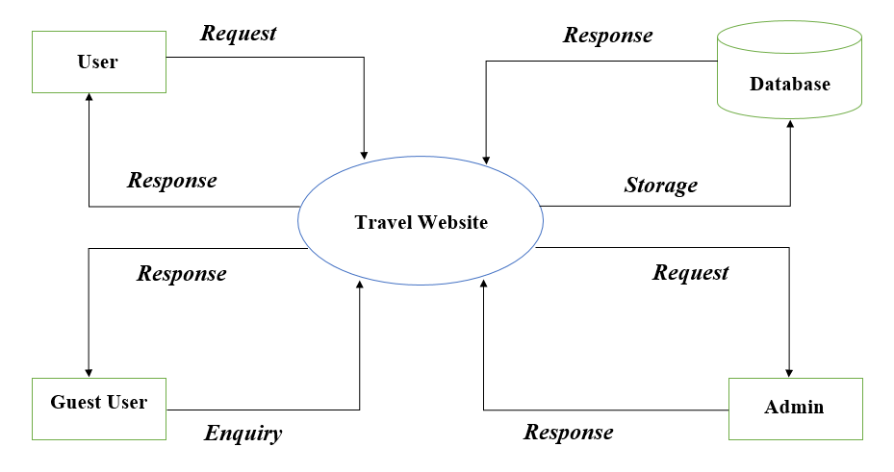**DATA FLOW DIAGRAM:-**

**Figure-2.1: Data Flow Diagram**

* 1. **HARDWARE AND SOFTWARE REQUIREMENTS:-**
     1. **Hardware Requirements:**

1. Processor (CPU)
2. Monitor
3. A minimum of 3MB of available space on the hard disk.
   * 1. **Software Requirements:**
4. Sublime text
5. Wamp server
6. **SYSTEM DESIGN**
   1. **ER DIAGRAM:**

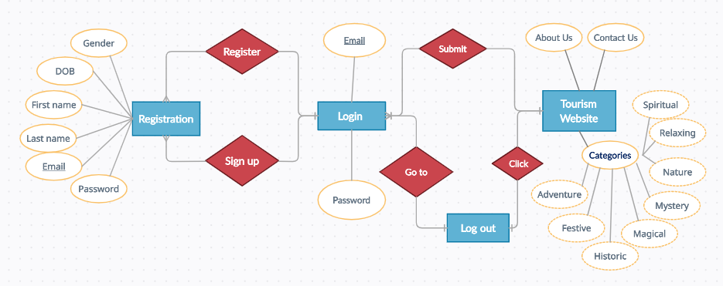**Figure-3.1: ER Diagram**

**Notations:-**

|  |  |  |  |
| --- | --- | --- | --- |
| 1 |  | **-** | **One** |
| 2 |  | **-** | **One or many** |
| 3 |  | **-** | **Many** |

An Entity Relationship (ER) Diagram is a type of flowchart that illustrates how “entities” such as people, objects or concepts relate to each other within a system. ER Diagrams are most often used to design or debug relational databases in the fields of software engineering, business information systems, education and research. Also known as ERDs or ER Models, they use a defined set of symbols such as rectangles, diamonds, ovals and connecting lines to depict the interconnectedness of entities, relationships and their attributes. They mirror grammatical structure, with entities as nouns and relationships as verbs.

* 1. **DATA TABLES:**

**Table-3.1: User Table**

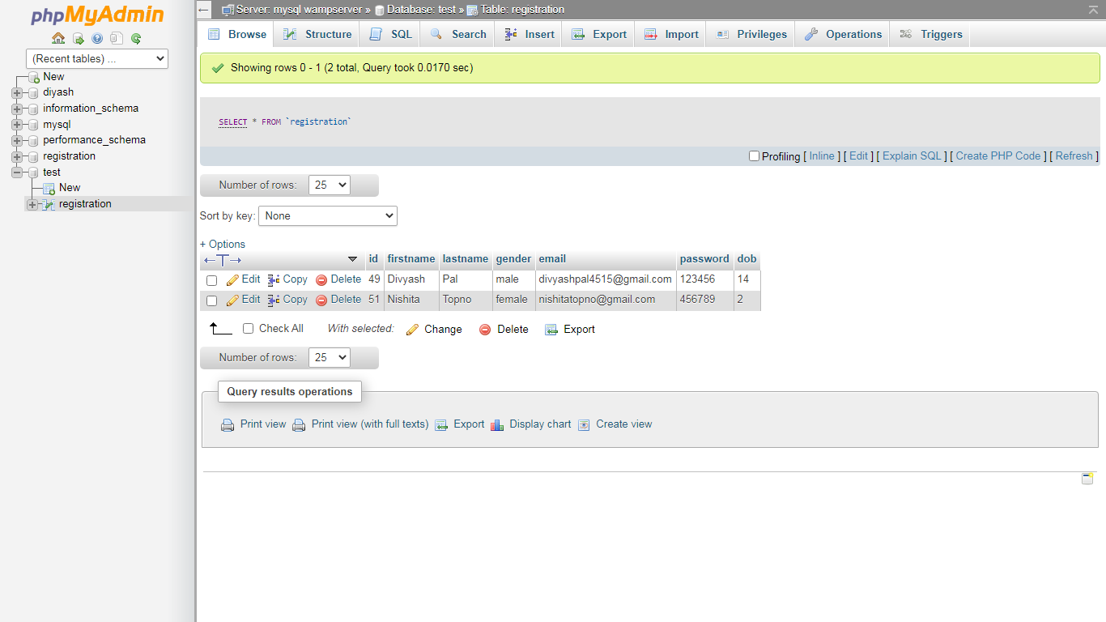

This table stores the data of users, which they fill in registration form. Login page checks email and password from this data table while user login to website.

1. **TOOLS USED**
   1. **FRONT END: -**

For front end we use HTML, CSS and Bootstrap.

**HTML** - Hyper Text Markup Language (HTML) is the set of markup symbols or codes inserted into a file intended for display on the Internet. The markup tells web browsers how to display a web page's words and images. With HTML we designed a basic web page for our website and basic registration as well as login page. We use tags which are required for example form tag in registration and login page.

**CSS** – CSS is used to define styles for your web pages, including the design, layout and variations in display for different devices and screen sizes. CSS was used in styling the web page, we connect css files to our html pages externally using link tag.

**Bootstrap** – With bootstrap we made our website responsive i.e. it will adjust according to the screen ratio, we use bootstrap grid system to make sit responsive and bootstrap also has some default templates like navigation bar, buttons etc.

* 1. **BACK END:**

For back end we use Php and MySQL.

**Php** - Stands for "Hypertext Preprocessor" (It is a recursive acronym, if you can understand what that means.) PHP is an HTML-embedded Web scripting language. This means PHP code can be inserted into the HTML of a Web page. When a [PHP page](https://fileinfo.com/extension/php) is accessed, the PHP code is read or "parsed" by the server the page resides on.

**MySQL** – MySQL is an Oracle-backed open source relational database management system ([RDBMS](https://searchdatamanagement.techtarget.com/definition/RDBMS-relational-database-management-system)) based on Structured Query Language ([SQL](https://searchsqlserver.techtarget.com/definition/SQL)). MySQL runs on virtually all platforms, including [Linux](https://searchdatacenter.techtarget.com/definition/Linux-operating-system), [UNIX](https://searchdatacenter.techtarget.com/definition/Unix) and [Windows](https://searchwindowsserver.techtarget.com/definition/Windows)

1. **TESTNG**
   1. **WHITE BOX TESTING**

White Box Testing is software testing technique in which internal structure, design and coding of software are tested to verify flow of input-output and to improve design, usability and security. In white box testing, code is visible to testers so it is also called Clear box testing, Open box testing, Transparent box testing, Code-based testing and Glass box testing.

* + 1. **Unit Testing:**

We tested all the pages of our website. While unit testing, we faced an error by the wamp server that shown below, but we solved it by proper back end connectivity.

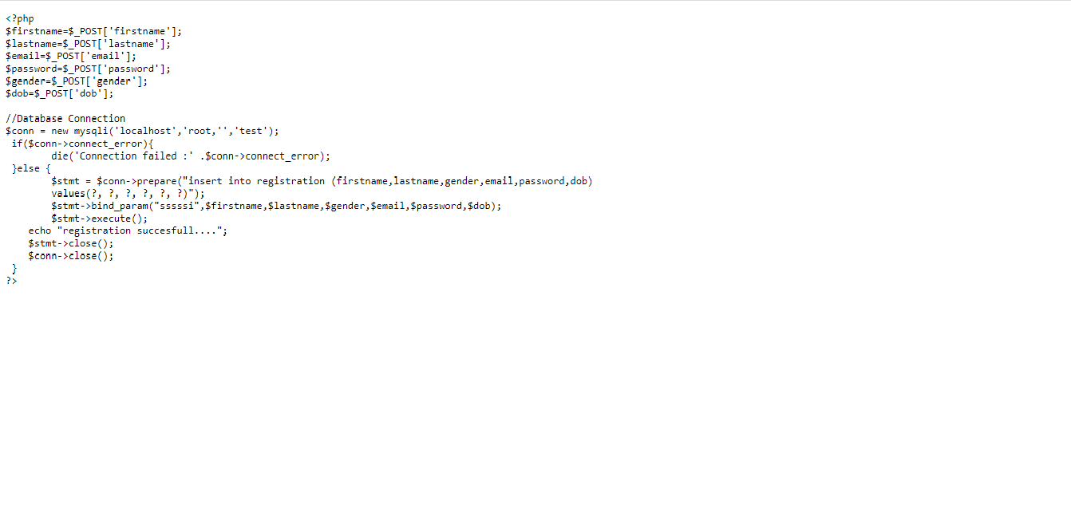

**Figure-5.1: Error**

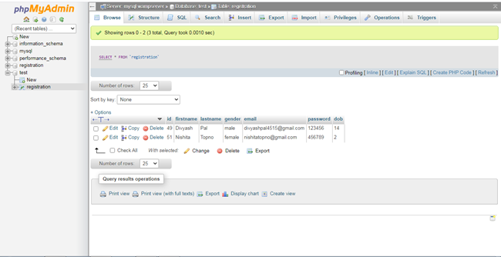

**Figure-5.2: Error**

We got another problem as in data base date of birth was not inserting in required format. We solved by concating date of birth data and giving proper data type for that.

* 1. **BLACK BOX TESTING**

Black Box Testing is a software testing method in which the functionalities of software applications are tested without having knowledge of internal code structure, implementation details and internal paths. Black Box Testing mainly focuses on input and output of software applications and it is entirely based on software requirements and specifications. It is also known as Behavioral Testing.

* + 1. **System Testing:**

While system testing, our website can implement in operating systems like windows 7, windows 8 etc.

* + 1. **Stress Testing:**

Our system behaves same under unfavorable condition

* + 1. **Performance Testing:**

We tasted the speed and effectiveness of the system and it is generating same results within a specified time as in performance requirements.

* + 1. **Usability Testing:**

The system is tested by clients and we conclude that the graphic user interface (GUI) is user friendly. The system can be operated by any generation of human.

* + 1. **Beta Testing:**

While Beta testing, we got an unexpected result by the system i.e. user can submit without filling registration form. But after we debug it by giving the required condition in code.

1. **IMPLEMENTATION**
   1. **FORMS LAYOUT**

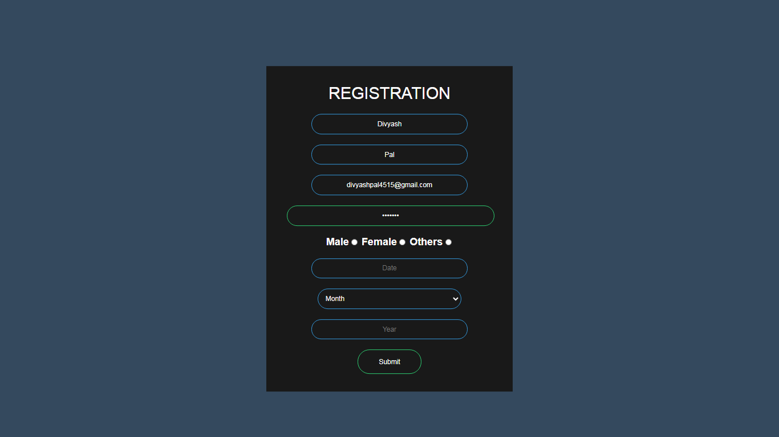

**Figure-6.1: Registration Page**

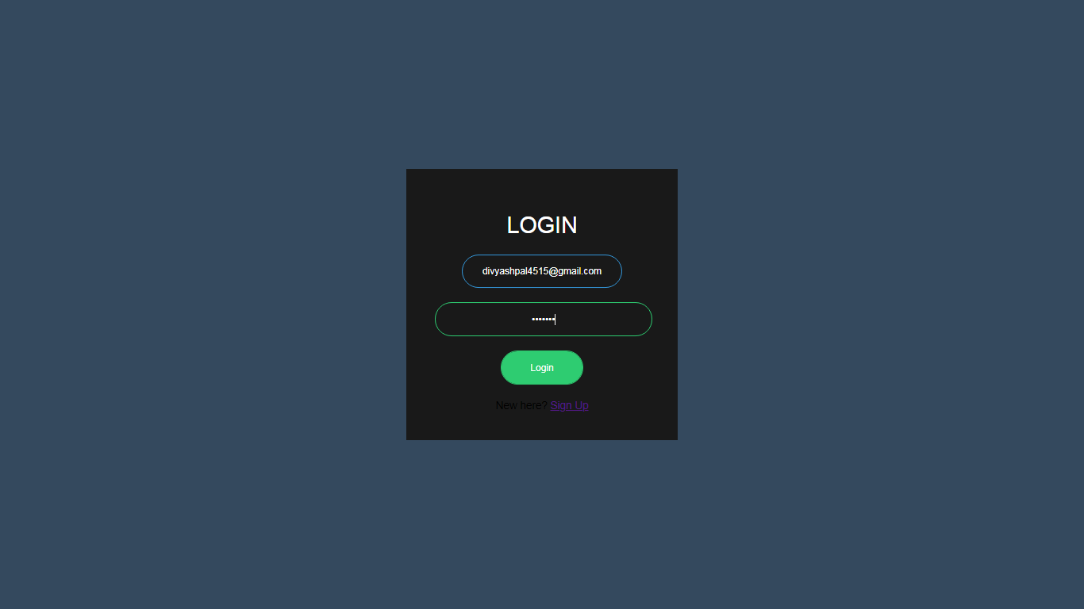**Figure-6.2: Login Page**

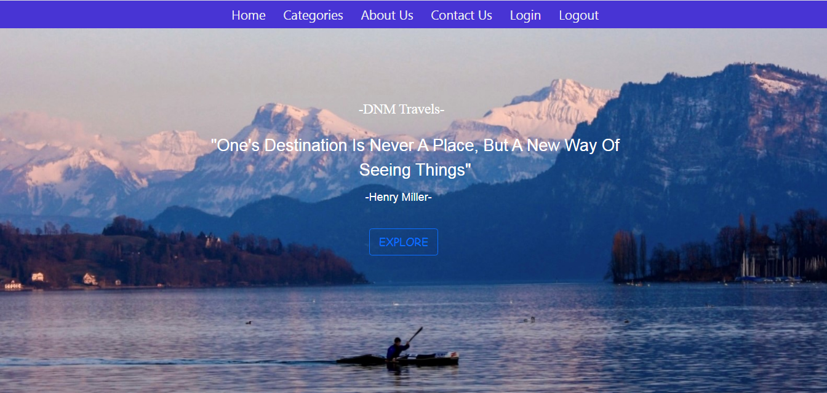

**Figure-6.3: Home Page**

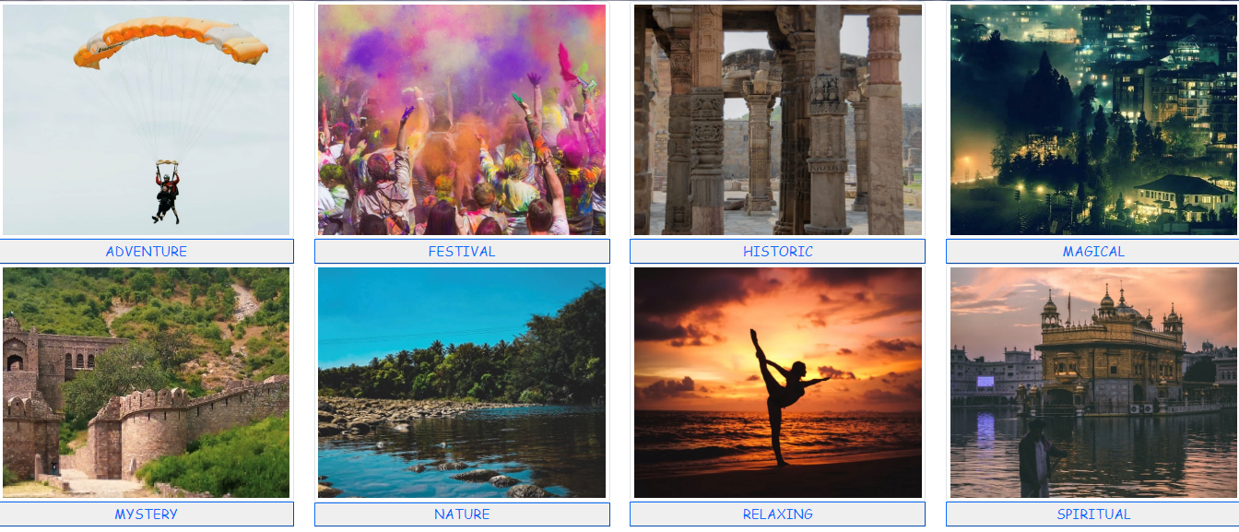

**Figure-6.4: Categories Page**

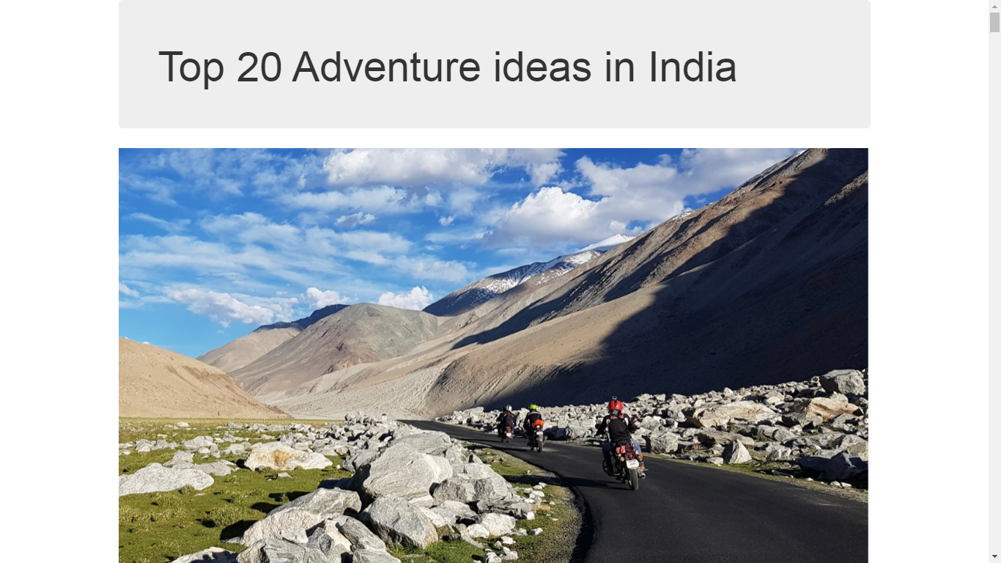

**Figure-6.5: Adventure page**

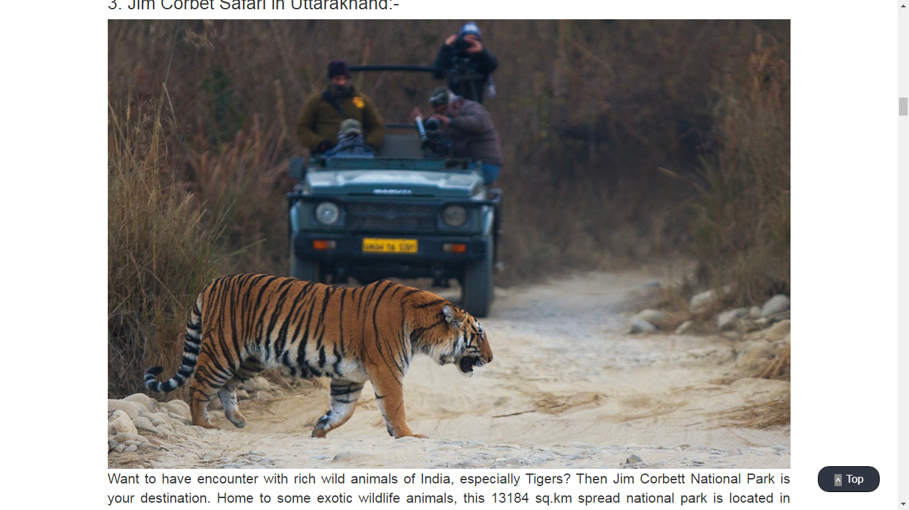

**Figure-6.6: Adventure Page**

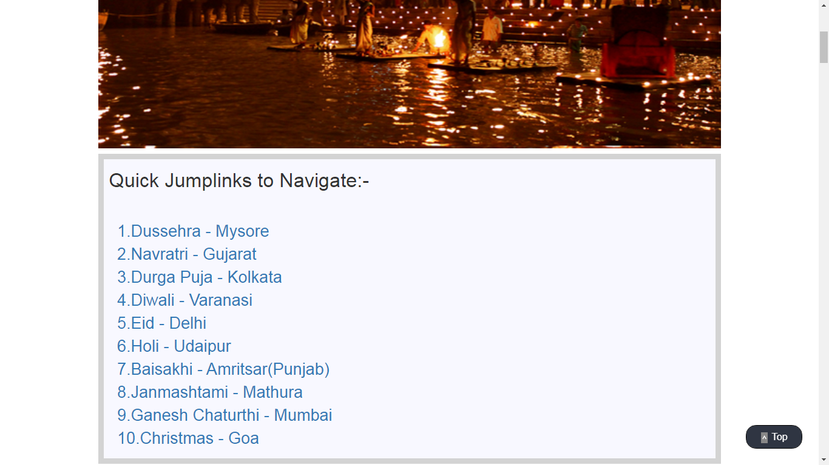

**Figure-6.7: Festives Page**

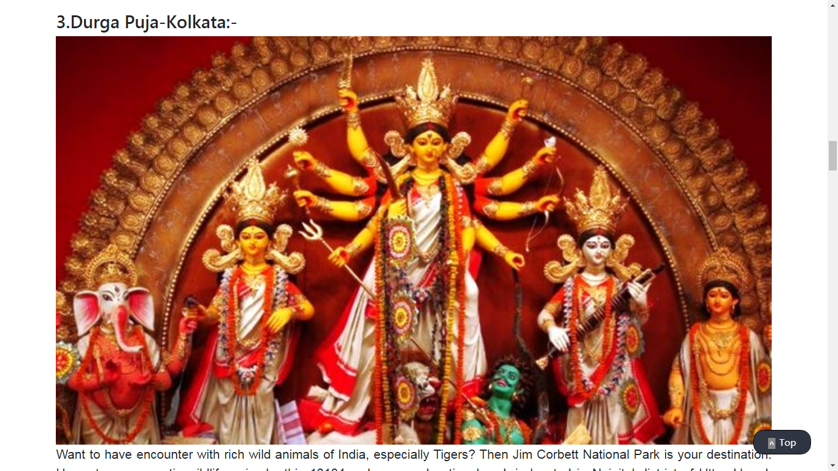

**Figure-6.8: Festives Page**

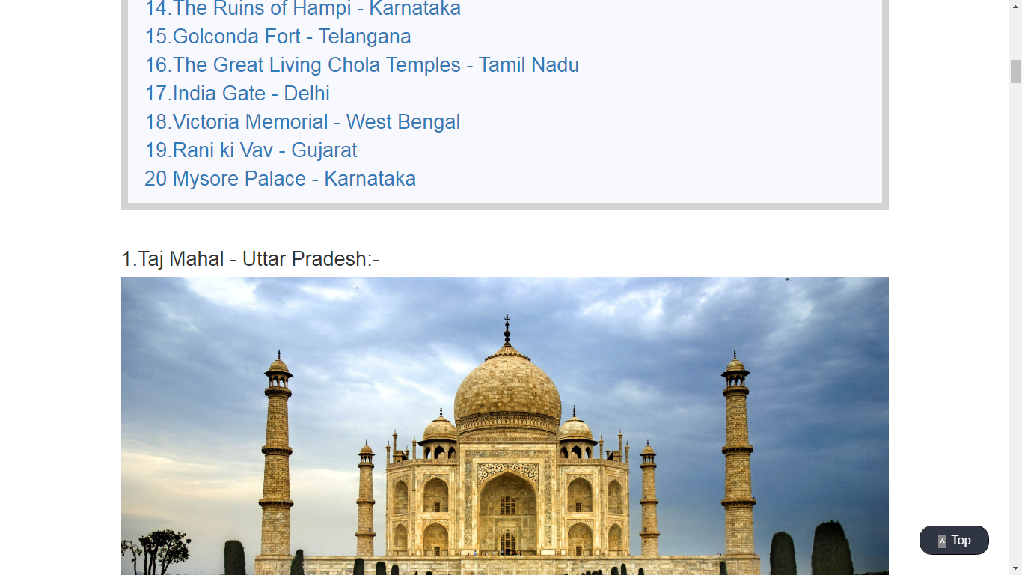

**Figure-6.9: Historic Page**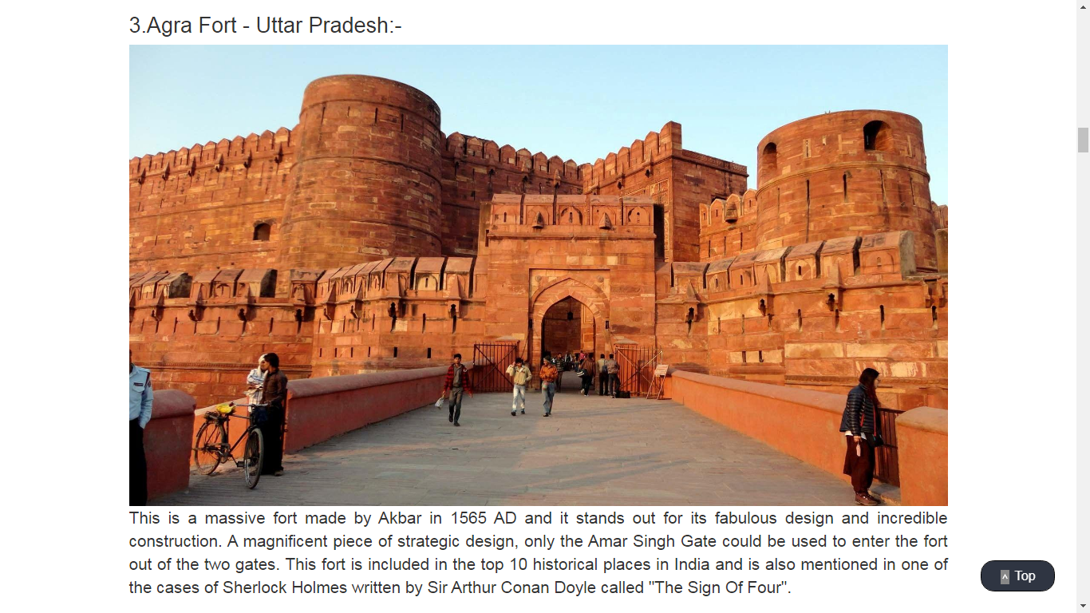

**Figure-6.10: Historic Page**

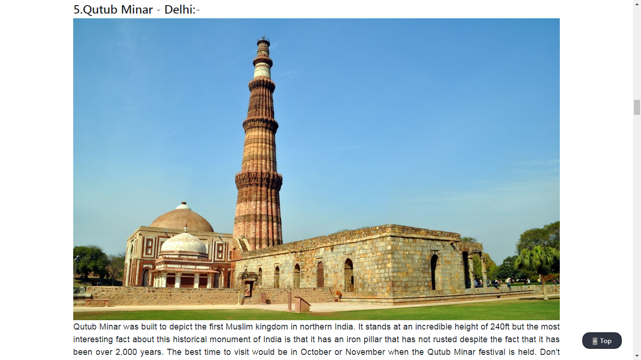

**Figure-6.11: Historic Page**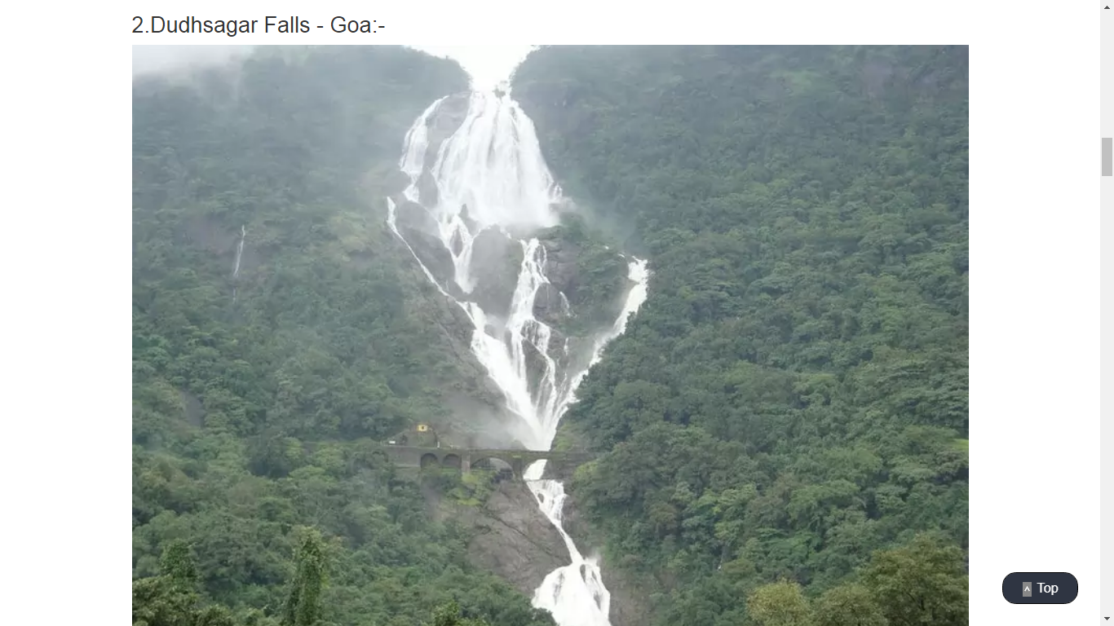

**Figure-6.12: Magical Page**

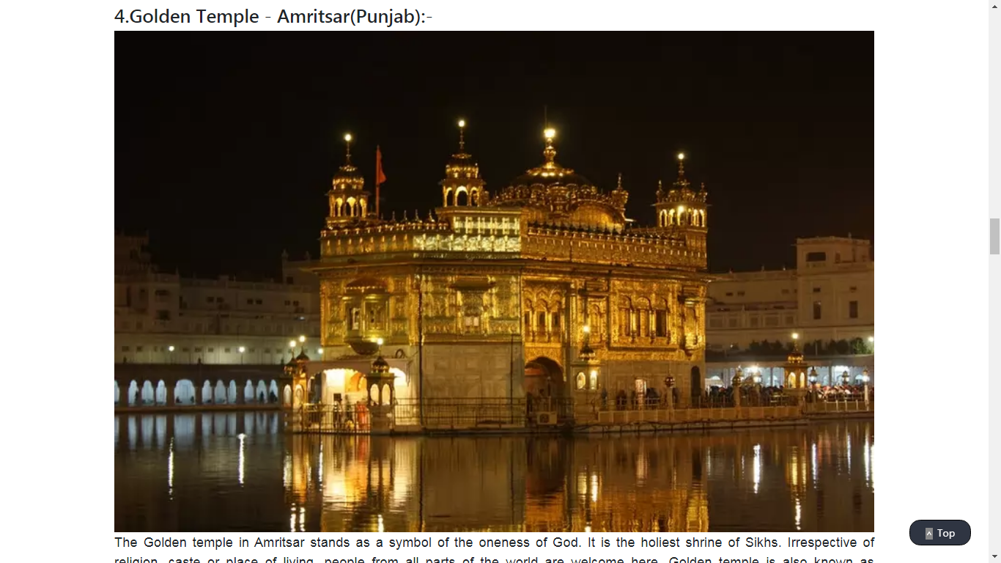

**Figure-6.13: Magical Page**

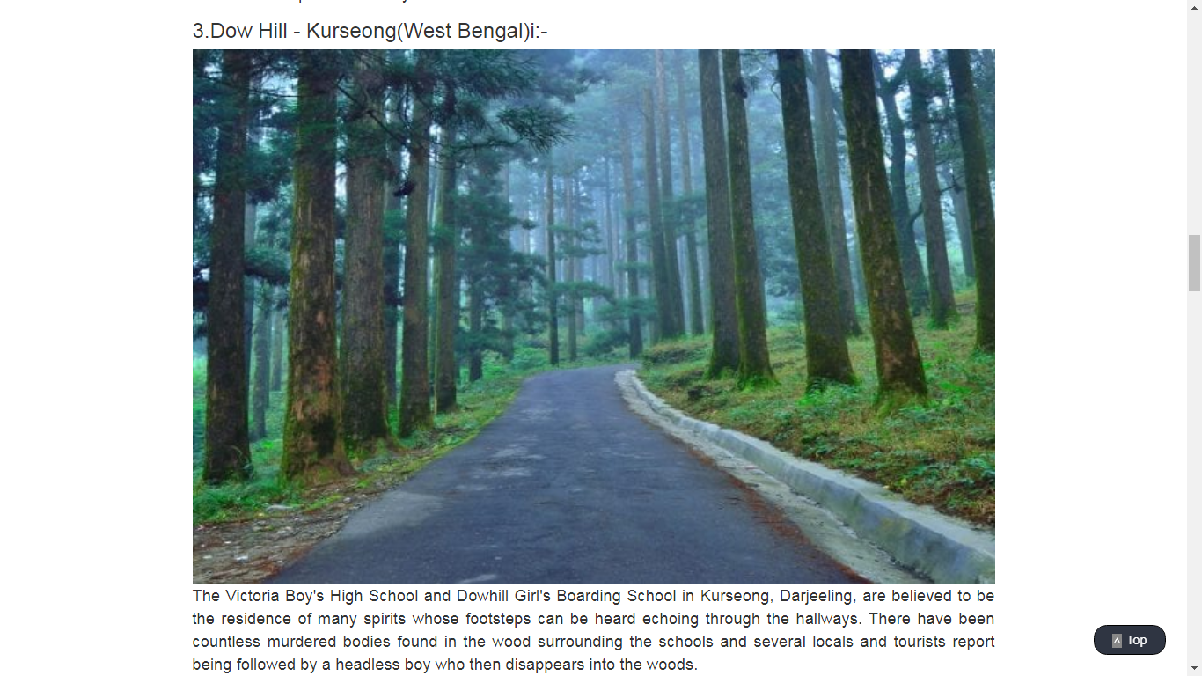

**Figure-6.14: Mystery Page**

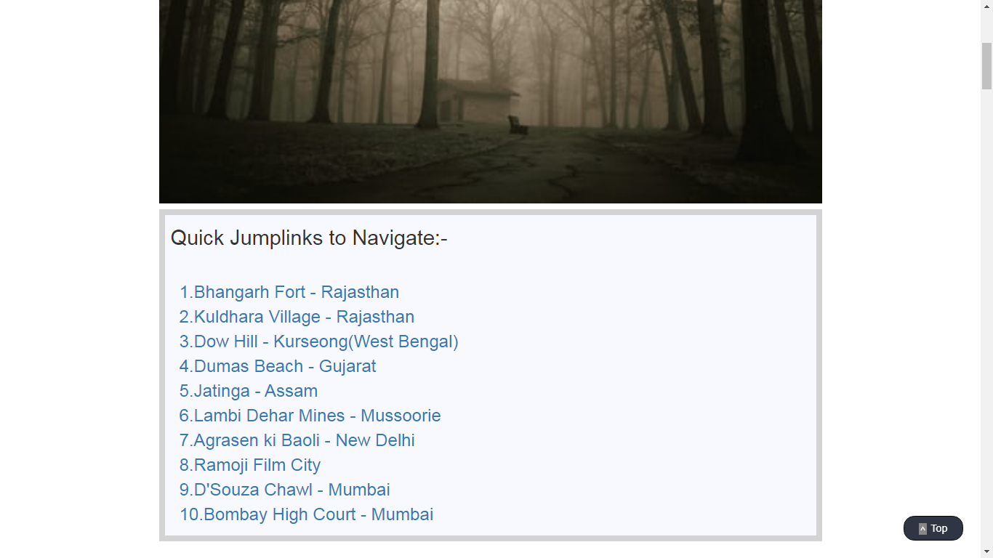

**Figure-6.15: Mystery Page**

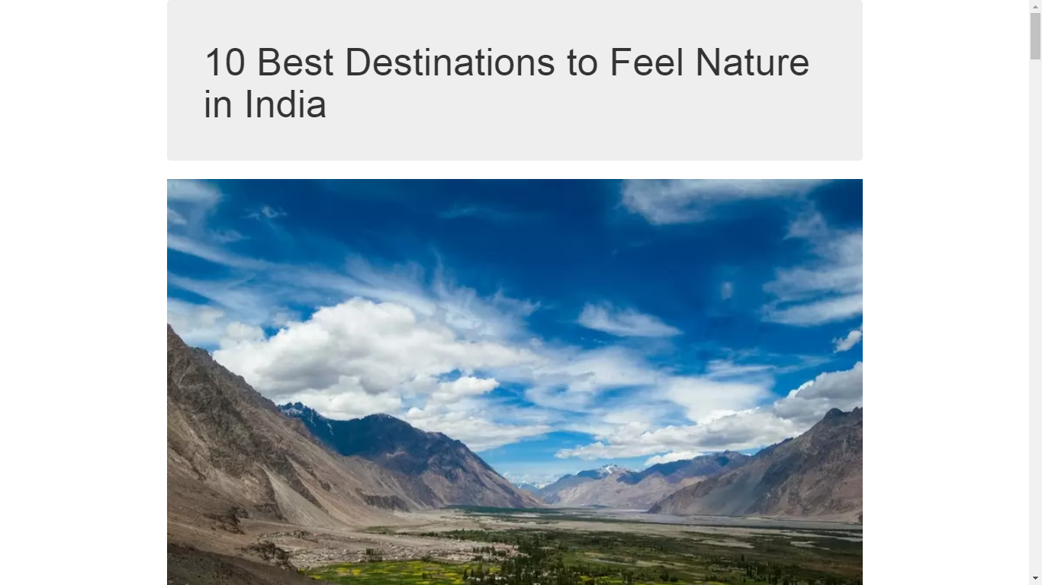

**Figure-6.16: Nature Page**

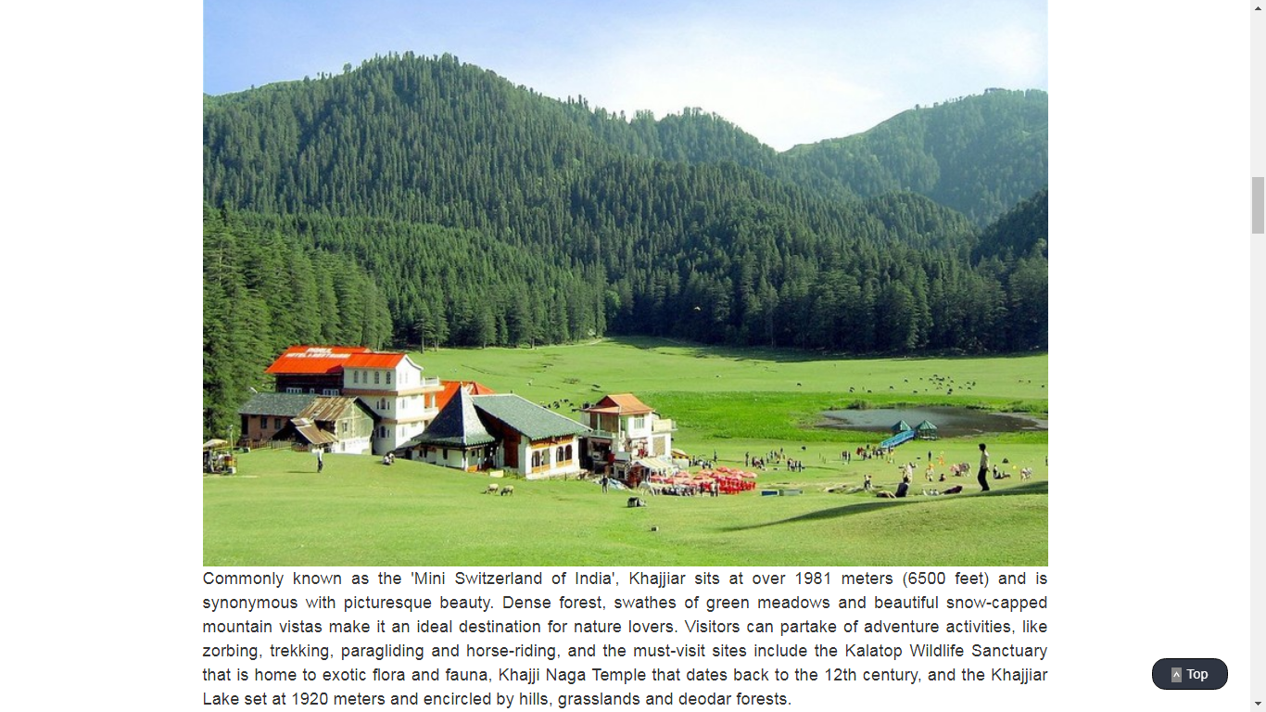

**Figure-6.17: Nature Page**

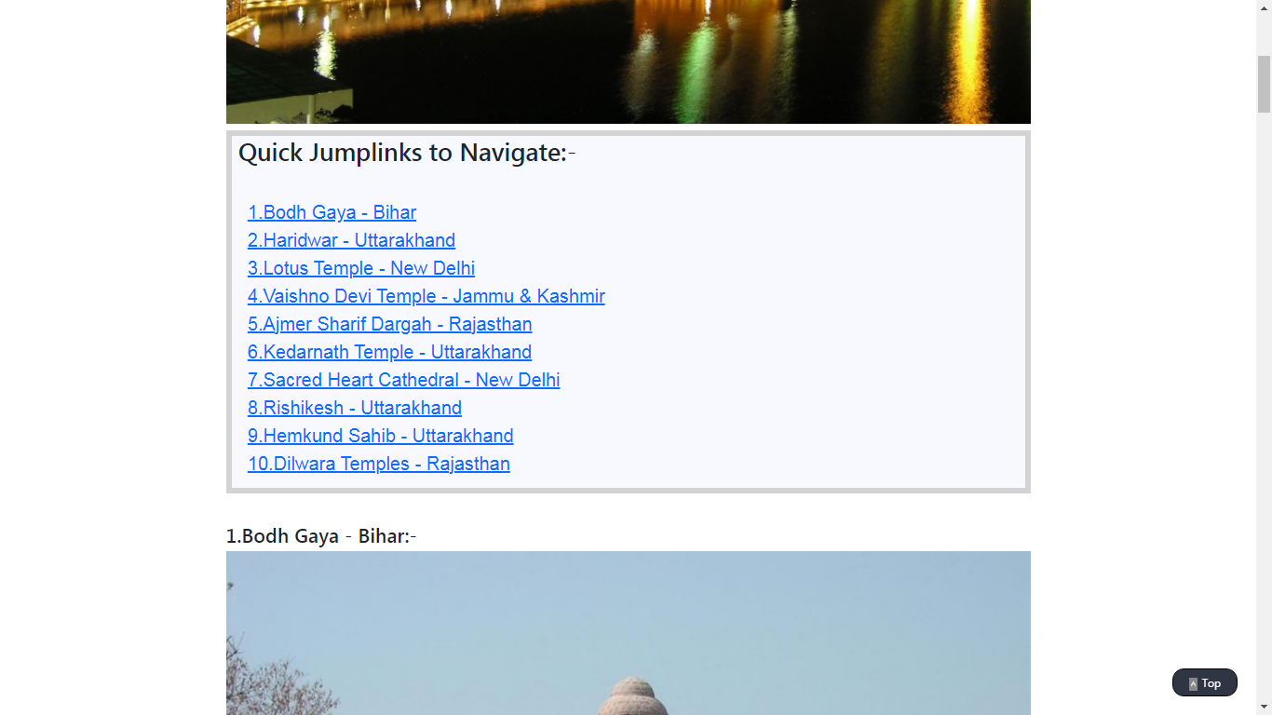

**Figure-6.18: Spiritual Page**

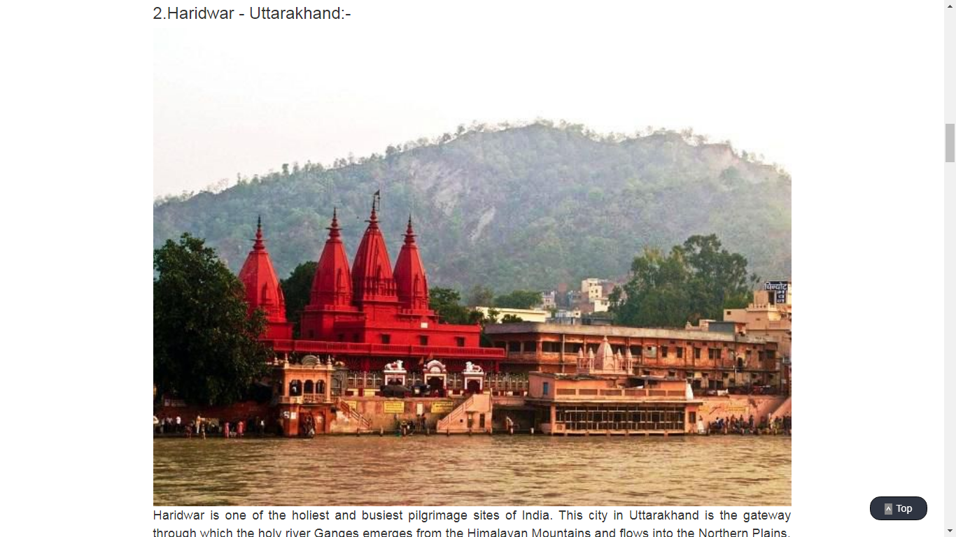

**Figure-6.19: Spiritual Page**

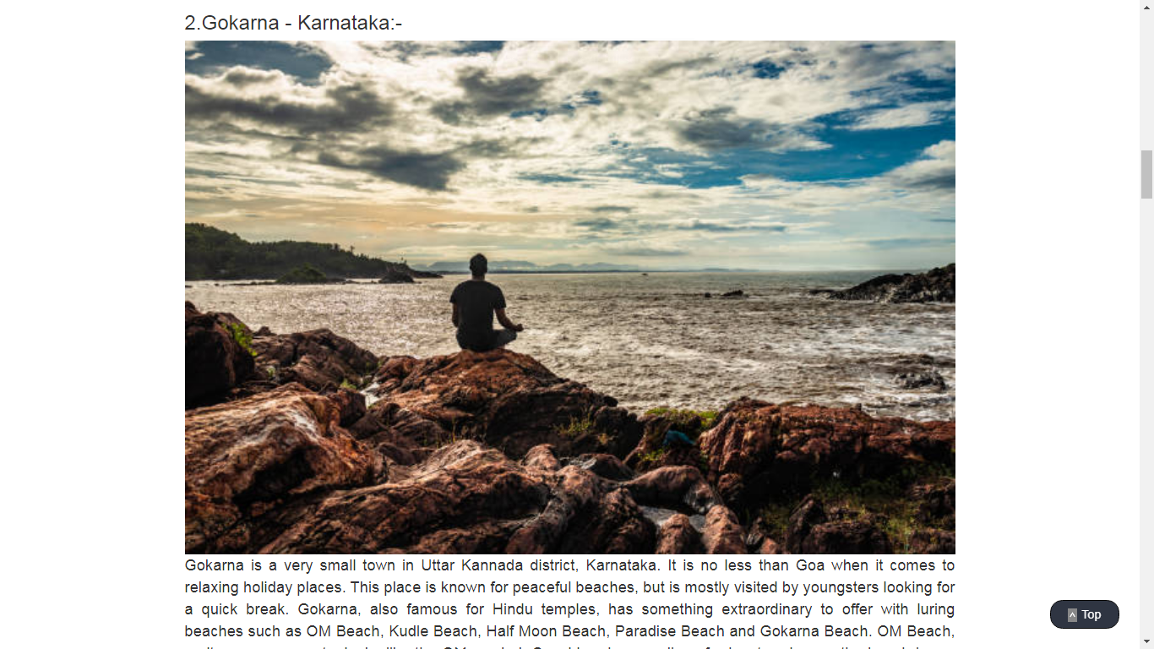

**Figure-6.20: Relaxing Page**

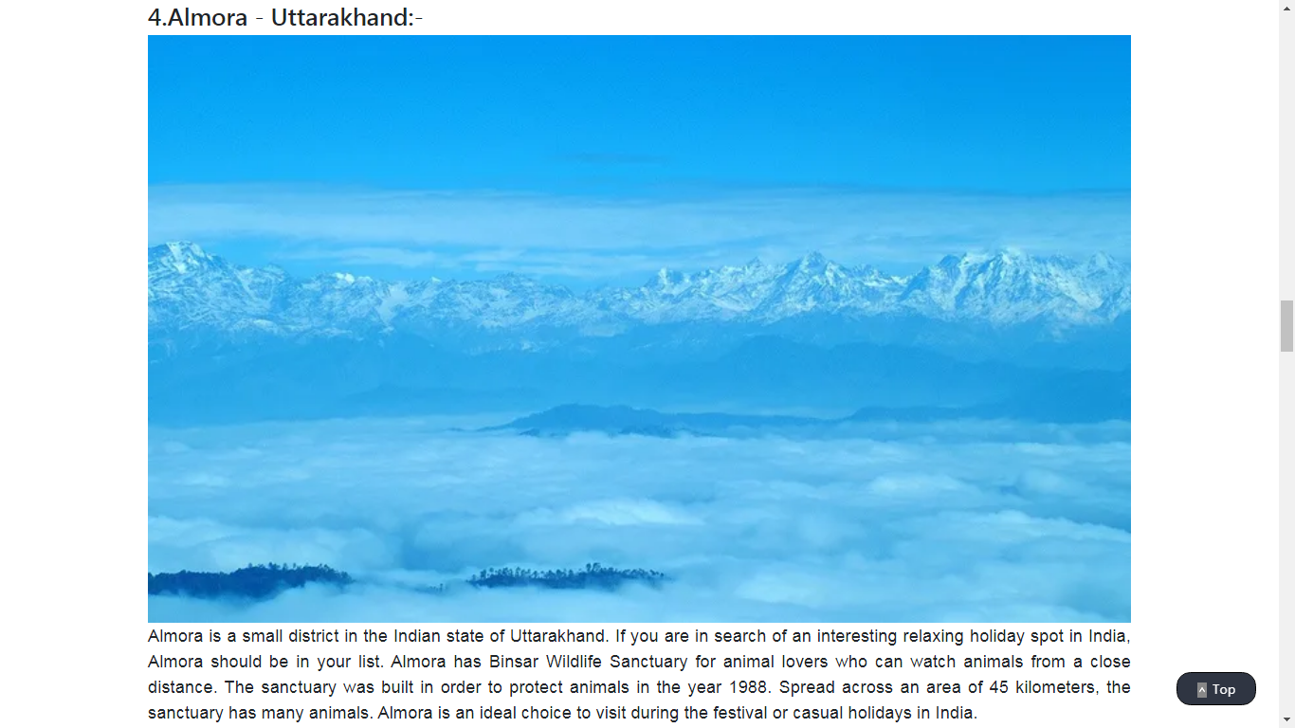

**Figure-6.21: Relaxing Page**

**CONCLUSION**

* 1. **SALIENT FEATURES OF THE SYSTEM**

The innovative design of this website is not just informative but it is totally unique and user friendly. With categorization of places one can easily choose destination to travel. They will get to know season fairs and many exciting places to visit, and what are COVID-19 protocols.

* 1. **LIMITATIONS OF THE SYSTEM**

This Tourism website is still in the planning stage. It doesn’t notify you for any updates. There is no any videos in this website. It will only give you information about tourist spots.

* 1. **SCOPE OF FUTURE ENHANCEMENTS**

There is a lot of scope of enhancement, can add booking slots for accommodation and booking for travel arrangements also. Can add budget bar as everyone decides their budget while planning for travel. Can provide travel packages too which will be linked with budget bar. There are many more possibilities for enhancements.

1. **BIBILIOGRAPHY**

To bring the project to a fruitful completion we have consulted several websites and books. We are giving a list of important books and websites. These are initial points of our research for this project.

* + - 1. **Book referred:**
         1. Douglas V. Hall, “Microprocessors and Interfacing-programming and Hardware”, 2nd edition, Tata McGraw Hill, 2002.
      2. **Websites referred:**

1. <https://www.w3schools.com/>
2. <https://www.youtube.com/>
3. <https://stackoverflow.com/>
4. <https://developer.mozilla.org/en-US/>